Baked Chicken with Herb Butter Sauce
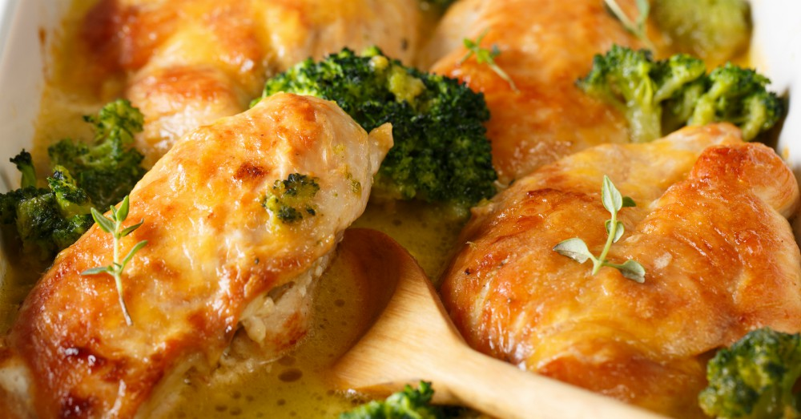
Prep Time 40 min
Ingredients
4 medium boneless skinless chicken breasts (about 1 1/2 pounds)
2 medium garlic cloves, minced
8 tbsp (stick) unsalted butter, divided
4 tbsp (¼ cup) Dijon mustard
1 cup low-sodium chicken broth
1 cup heavy cream
2 tbsp fresh thyme leaves, chopped, plus extra for garnish
Kosher salt
Ground pepper
Short pasta of choice
Directions
- Cook pasta according to package directions.
- Melt 1 tablespoon butter in large skillet over medium heat. Season chicken breasts with salt and pepper. Cook 6 to 8 minutes per side to brown. Let chicken rest for 10 min, then shred.
- Add remaining butter to skillet. Sauté garlic until fragrant, about 1 minute.
- Pour in chicken broth and use spoon to loosen any browned bits on bottom of pan. Stir in Dijon mustard, cream, and thyme. Simmer 3 to 5 minutes and stir until thickened.
- Combine sauce and pasta. Let sit for 5 minutes.
- Add in chicken. Stir to combine.

